First Author’s Name SURNAME¹, (style: Authors)
Second Author’s Name SURNAME²

¹ [name of the institution] (style: Affiliation)
[name of the institution part 2]
[street, postcode, city, country]

For example:
² Siedlce University of Natural Sciences and Humanities
Institute of Computer Science,
ul. 3 Maja 54, 08-110 Siedlce, Poland

Title of the paper (style: Title)
Abstract. [Please insert paper’s abstract here] (style: Abstract and keywords)
Keywords. [Please insert paper’s keywords here] (style: Abstract and keywords)

Introduction (style: Section)
Papers must be written in English and include original material, not published or being considered elsewhere. Manuscripts should be prepared in Microsoft Word (docx format), contain up to 12-16 pages.

Typesetting

Page Setup (style: Subsection)
You should choose the A4 (210x297 mm) paper size and the portrait orientation. Set the margins to 2.5 cm for each side.

Styles in text
Please use attached Word styles in this document. Next to each part of the paper you are provided name of the style. Please use this style. Do not add any extra lines.

Figures
Insert figures in bitmap (PNG, JPG) or (preferred) vector format (SVG). Please centre the figure. Please put the figure’s title under of the figure.
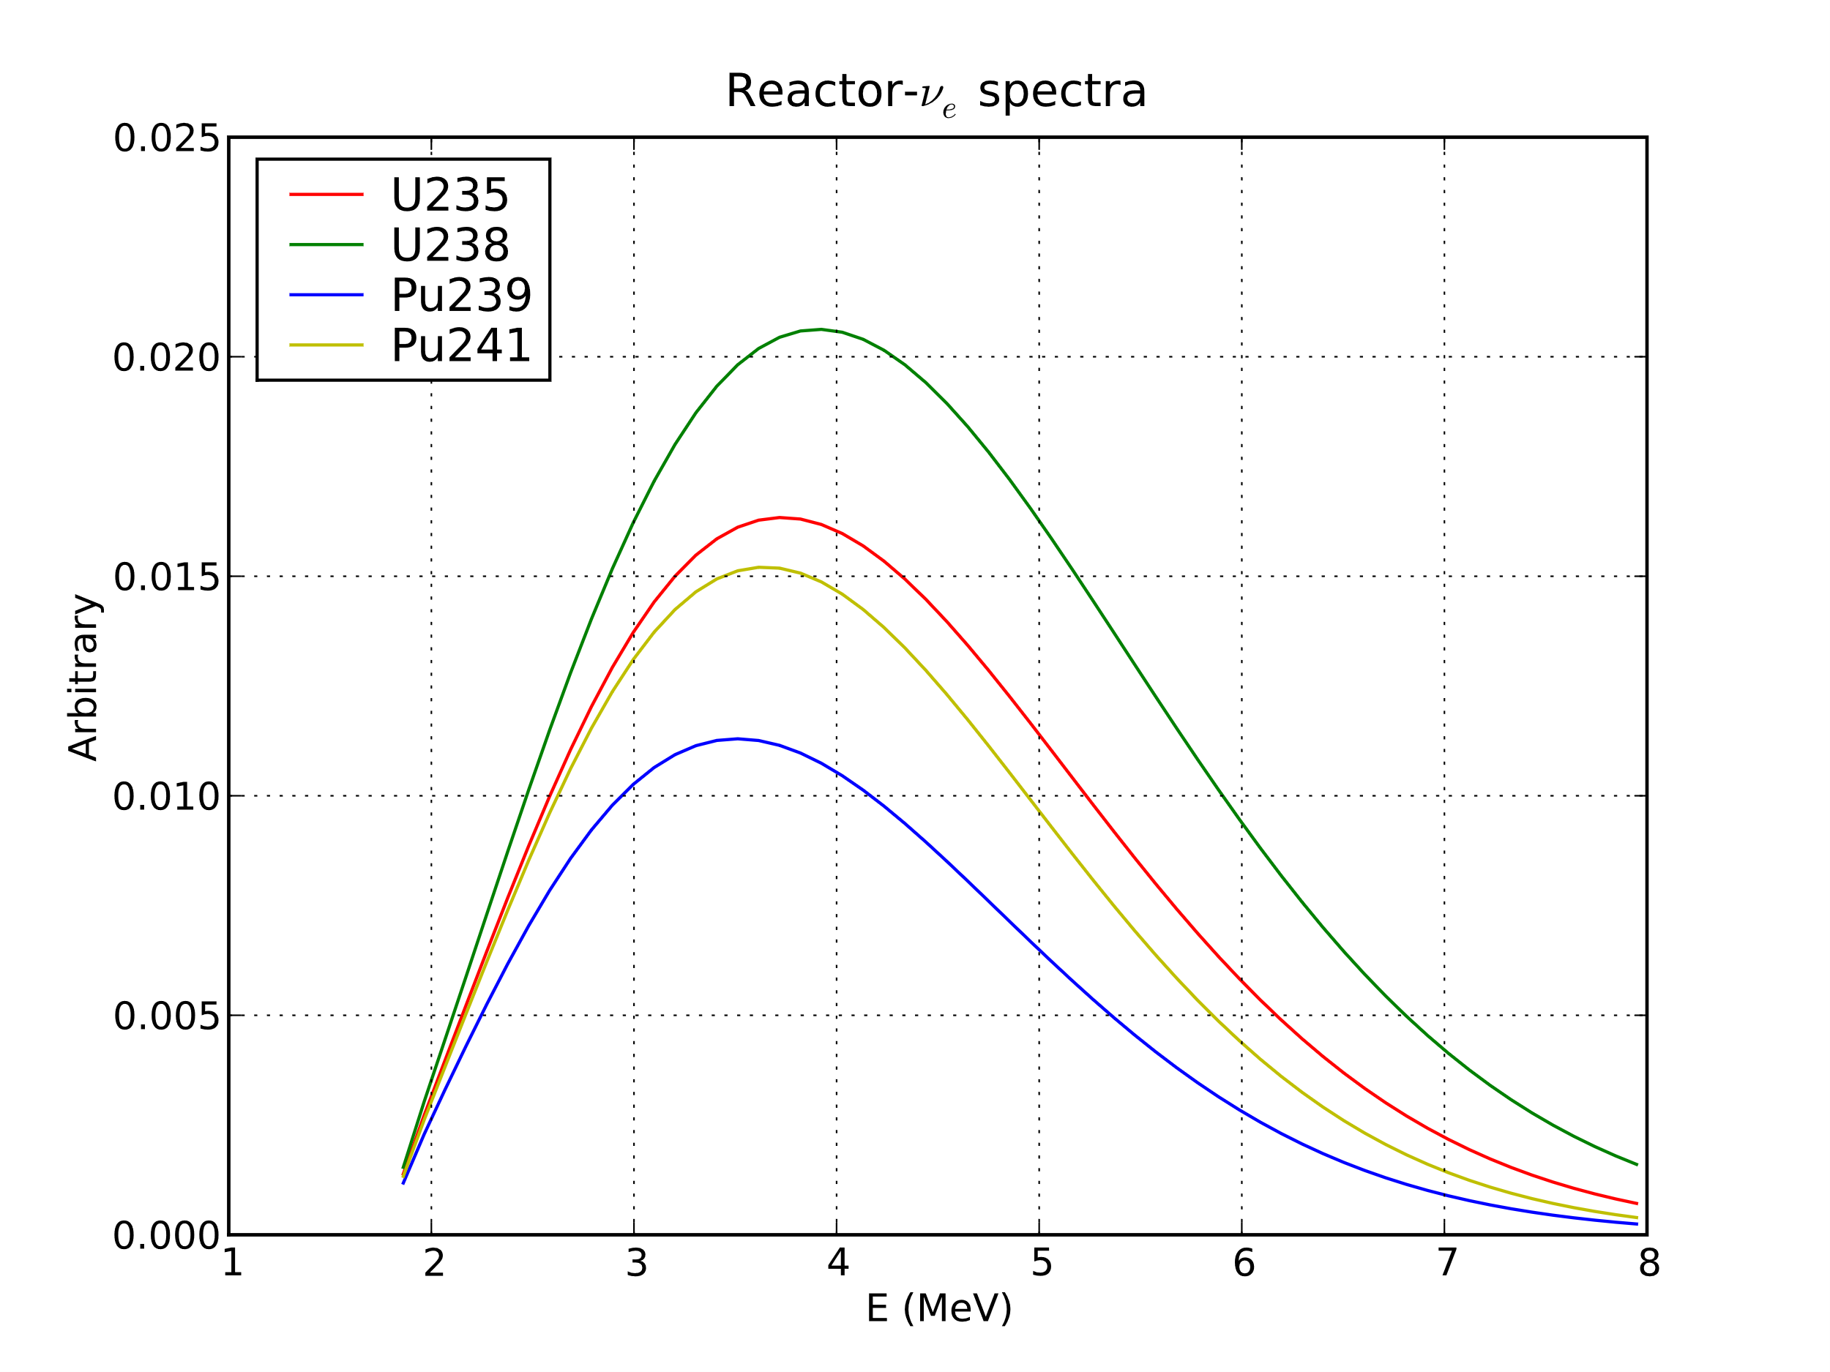
Figure 2.1. An example of the figure (style: Figures and tables title)

Tables
Please put the table’s title above the table.
Table 2.1. An example of the table. (style: Figures and tables title)
(style for tables: Table)
Time | Sequence A | Sequence B | Sequence C
Step 1 | n/a | n/a | n/a
Step 2 | 00:25 | 02:35 | 03:20
Step 3 | 06:20 | 06:20 | 05:45
Sum | 06:45 | 08:55 | 09:05
References (style: References title)
Please put the references according to the following example:
- Stano P. M., den Dekker, A. J., Lendek Z., Babuska R.: Convex Saturated Particle Filter, Automatica, vol. 50, pp. 2494-2503, 2014. (style: References)
- Yang T., Blom H. A., Mehta P. G.: Interacting Multiple Model-Feedback Particle Filter for Stochastic Hybrid Systems, Proceedings of the IEEE Annual Conference on Decision and Control (CDC), pp. 7065-7070, 2013.

